Project Design Phase-II
Data Flow Diagram & User Stories

Date | 31 January 2026
Team ID | LTVIP2026TMIDS60355
Project Name | Calculating family expenses using service now
Maximum Marks | 4 Marks

Data Flow Diagrams:
A Data Flow Diagram (DFD) is a traditional visual representation of the information flows within a system. A neat and clear DFD can depict the right amount of the system requirement graphically. It shows how data enters and leaves the system, what changes the information, and where data is stored.
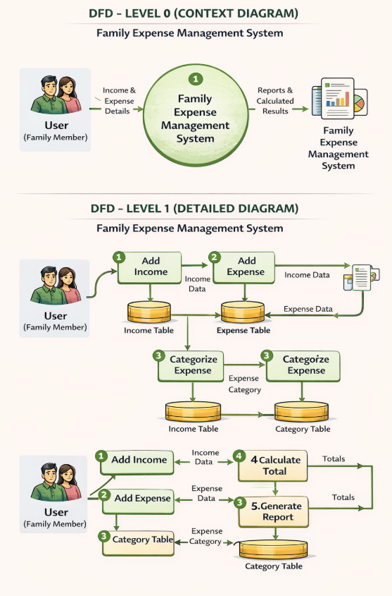
User Stories
Use the below template to list all the user stories for the product.

User Type | Functional Requirement (Epic) | User Story Number | User Story / Task | Acceptance Criteria | Priority | Release
Family Member (Mobile User) | Registration | USN-1 | As a user, I can register by entering name, email, and password | I can successfully create an account and access dashboard | High | Sprint-1
Family Member (Mobile User) | Login | USN-2 | As a user, I can log in using email and password | I can access my dashboard after valid login | High | Sprint-1
Family Member (Mobile User) | Income Management | USN-3 | As a user, I can add my income details | Income data is stored in Income table | High | Sprint-1
Family Member (Mobile User) | Expense Management | USN-4 | As a user, I can add daily expense with date, amount, and category | Expense data is stored correctly in Expense table | High | Sprint-1
Family Member (Mobile User) | Category Management | USN-5 | As a user, I can categorize expenses (Food, Rent, etc.) | Expenses are linked to selected category | Medium | Sprint-2
Family Member (Mobile User) | Calculation | USN-6 | As a user, I can view total monthly expenses automatically | System calculates total expenses correctly | High | Sprint-2
Family Member (Mobile User) | Savings Calculation | USN-7 | As a user, I can see my savings (Income – Expense) | Savings are displayed correctly on dashboard | High | Sprint-2
Family Member (Web User) | Reports & Dashboard | USN-8 | As a user, I can generate monthly reports | System generates accurate reports and charts | Medium | Sprint-3
Administrator | User Management | USN-9 | As an admin, I can manage user accounts | Admin can view, activate, or deactivate users | Medium | Sprint-3

